1. Frontend
2. Using html, CSS for desinging interface,
3. JavaScript/JSON/XML for data exchange from server to client. To ensure the client interprets JSON data correctly, we should set the Content-Type type in the response header to application/json while making the request.
4. Always use regular HTTP status codes in responses to requests made to your API. This will help your users to know what is going on – whether the request is successful, or if it fails, or something else.

Homepage must have the following basic information;

1. Contact
2. Bakery profile
3. Bakery history
4. Customer feedback
5. Backend RESTful API
6. Use JSON as the Format for Sending and Receiving Data.
7. For server-side frameworks, set the Content-Type automatically. Express, for example, now has the express.json() middleware for this purpose. The body-parser NPM package still works for the same purpose, too.
8. The endpoints should use nouns, signifying what each of them does.
9. Using C# programming language
10. Database using MySQL

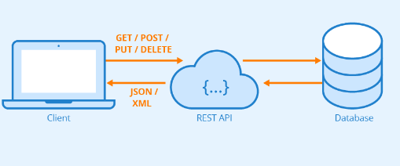

1. Items listing page;
2. Products and
3. Menus
4. Price
5. Buy button or add to cart button
6. Item detail page;
7. Summary of Products
8. Product Name
9. Product Code
10. Product Price
11. Total of Items
12. Total amount
13. Item add/update page;
14. Submit button
15. add to cart button